POLYRIB PTY LTD
PORT CAPITAL SERIES
Grease Traps and Grease Arrestors
Product Information, Installation,
Maintenance & Warranty Manual
Current PCGT1000-PCGT5000 model range
A practical customer handover manual for installation, commissioning, operation and maintenance.
Manufactured, Supplied & Supported by Polyrib Pty Ltd
Revision G | Issue date: 18 October 2026
IMPORTANT: Retain this manual with the property and provide it to future owners, operators and service contractors.

Important information
Purpose, responsibility and document status
READ BEFORE INSTALLATION: This manual must be read with the project drawings, product order information and applicable local authority requirements. Installation must be completed by a licensed plumber.

About Polyrib and the Port Capital Series
The Port Capital Series is Polyrib Pty Ltd's specialist grease-trap product range for commercial, industrial and trade-waste applications. Port Capital is used as a product brand only; it is not a separate company or warranty provider.
Polyrib Pty Ltd manufactures, supplies, supports and warrants the products it supplies in the Port Capital Series, providing product information, installation guidance and ongoing technical support.

1. Document purpose
This manual provides customer handover information for Polyrib Port Capital Series grease traps manufactured, supplied and supported by Polyrib Pty Ltd. It covers product operation, site preparation, installation, commissioning, maintenance and warranty requirements.
These are Polyrib's official installation, operation and maintenance instructions. They do not replace project-specific hydraulic, structural, geotechnical or local authority requirements.

2. Responsibility and compliance
- Confirm the selected model, invert levels, access requirements and site conditions before excavation.
- Obtain all permits, trade-waste consents and local authority approvals required for the project.
- Polyrib Port Capital Series grease traps are designed for installation in accordance with AS/NZS 3500, applicable trade-waste authority requirements and the installation instructions contained in this manual. Current certification and individual authority acceptance must be confirmed for the applicable model and installation location.
- Where traffic loading, groundwater, unstable ground or unusual installation conditions apply, obtain project-specific professional advice before work starts.
- Obtain written confirmation of current certification and individual authority acceptance for the applicable model and installation location before installation.
CERTIFICATION AND AUTHORITY ACCEPTANCE: Current certification and individual authority acceptance must be confirmed for the applicable PCGT model and installation location. Legacy certificates or approvals must not be represented as current unless verified in writing.

Product overview
How the grease trap works and how it is constructed

3. Product overview
Polyrib Port Capital Series grease traps are intended to receive greasy wastewater and separate grease, oils and settleable solids before the wastewater continues to the downstream drainage system. The current range shown in this manual comprises PCGT1000, PCGT1500, PCGT2000, PCGT3000, PCGT4000 and PCGT5000 models.
BACKED BY POLYRIB: Every grease trap supplied by Polyrib in the Port Capital Series is supported by Polyrib Pty Ltd, providing customers, plumbers and project stakeholders with product information, installation guidance and ongoing technical support.

4. Benefits and standard features
- Rotationally moulded HDPE vessel. A lightweight, corrosion-resistant tank with integral external ribbing.
- High-level inlet arrangement. Supports grease separation within the vessel.
- Internal baffles. Control flow through the treatment chamber.
- Pipe connections. The typical cross-section shows the earlier DN100 connection arrangement. Confirm inlet, outlet and vent sizes for the new model supplied before installation.
- Service access. Access openings are provided for inspection and pump-out; sizes vary by model.
- Installation flexibility. The range is suitable for above-ground or below-ground installation when installed in accordance with this manual and the approved site design.

5. Operating principle
- Inflow enters the vessel. The incoming wastewater slows as it enters the grease trap.
- Grease separates. Grease and oils rise by buoyancy and are retained near the liquid surface.
- Solids settle. Heavier settleable material collects toward the bottom of the vessel.
- Flow passes the baffles. The internal arrangement reduces short-circuiting and assists separation.
- Effluent leaves through the outlet. Regular pump-out is required to maintain storage space and operating efficiency.

6. Product design and construction
The vessel is a ribbed HDPE structure with moulded access risers, internal baffles and connection points. External ribbing contributes to structural support when the tank is installed in accordance with the approved installation requirements. The vessel must not be relied on to carry traffic or surface loads unless a separate load-bearing design has been provided.

7. Current model range and typical cross-section
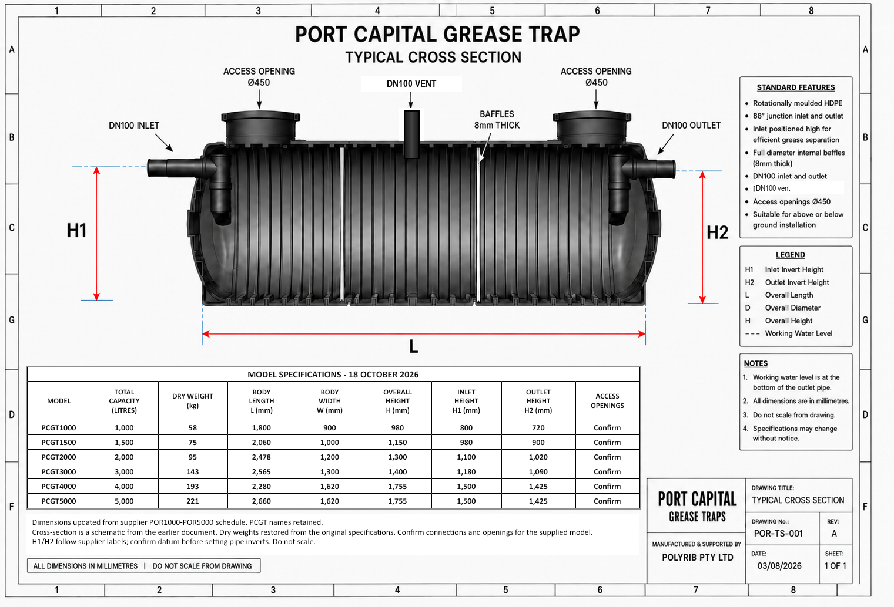
Figure 1. Typical cross-section and updated October 2026 dimension schedule. Cross-section details are schematic; confirm connections and access openings for the new model.

Access and connections
Inspection openings, risers, inlet, outlet and vent

8. Inspection openings, access covers and risers
- Keep every access opening readily accessible from finished surface level for inspection, pump-out and maintenance.
- Below-ground covers and frames must comply with AS 3996. Use Class D covers and frames where required by the site loading or the relevant authority.
- The maximum permitted riser height is 900 mm unless a greater height is approved in writing by Polyrib Pty Ltd and the relevant authority. Seal and support all risers and maintain safe finished-surface access.
- Extension risers do not increase the working or storage capacity of the grease trap.
- Do not transfer surface or traffic loads to the vessel or risers. Where traffic loading applies, provide an independently supported concrete surround or other load-bearing structure designed for the site.
ACCESS COVERS AND RISERS: Below-ground covers and frames must comply with AS 3996, with Class D used where required by site loading or the relevant authority. Maximum riser height is 900 mm unless Polyrib Pty Ltd and the relevant authority approve otherwise.

9. Inlet, outlet and vent connections
- The typical cross-section depicts the earlier DN100 inlet, outlet and PVC vent arrangement. Confirm connection diameters and materials against the new model supplied and the approved project design before installation.
- Confirm all pipe materials, adaptors, gradients, invert levels and expansion provisions before connection.
- Support connected pipework independently so that the vessel connections are not subjected to pipe weight, movement or installation stress.
- Route the vent to a suitable discharge point in accordance with the applicable plumbing and local authority requirements.
- Check all connections for obstruction and leakage during commissioning.

Pre-installation requirements
Checks to complete before excavation or delivery

10. Pre-installation requirements
- Verify the product. Confirm the model, capacity, access-opening arrangement, inlet and outlet invert heights, overall dimensions and delivery condition against the order and Figure 1.
- Confirm approvals. Check local authority, trade-waste, plumbing and building requirements. Obtain written acceptance where required.
- Locate services. Complete the relevant before-you-dig/service-location process and identify all underground and overhead hazards.
- Assess the site. Confirm groundwater, drainage, soil stability, excavation support, flood exposure, traffic loading and access for maintenance vehicles.
- Confirm levels. Check finished surface level, inlet and outlet levels, fall, riser height and pump-out hose access.
- Plan lifting. Obtain the confirmed dry weight for the model supplied and prepare suitable equipment and a safe lifting method for the site conditions.
- Inspect the vessel. Do not install a tank that is damaged, distorted or missing required components. Record damage before installation.
LIFTING RESTRICTION: Never lift, drag or restrain the grease trap by the inlet, outlet, vent or connected pipework. Use an approved lifting method and comply with workplace health and safety requirements.

DESIGN RESPONSIBILITY: The installer and project designers remain responsible for site-specific excavation, shoring, structural support, groundwater control, surface loading and connection design.

Below-ground installation
General sequence for normal in-ground conditions

11. Below-ground installation instructions
- Excavate safely. Provide at least 150 mm clearance around the vessel for bedding, connections and safe working access. Shore or batter the excavation as required.
- Prepare the base. Provide a minimum 50 mm layer of compacted bedding sand, level and fully supporting the tank. Do not place the tank on sharp objects, uneven material or unsupported fill. On unstable ground, provide a minimum 75 mm concrete slab, subject to site engineering.
- Lower the tank into position. Use an approved lifting method. Do not use the pipe connections as lifting points.
- Check alignment and levels. Confirm the vessel is level, correctly oriented and positioned so that all pipework can be installed without stress.
- Install and support connections. Connect inlet, outlet and vent pipework. Provide independent pipe support and required inspection openings at finished surface level.
- Fit risers and access arrangements. Seal and support risers and frames. Do not exceed a riser height of 900 mm unless Polyrib Pty Ltd and the relevant authority approve otherwise in writing.
- Fill and leak-check. Fill the vessel with clean water to its operating level. Inspect the tank and all connections for leaks and obstructions.
- Backfill progressively. Keep the vessel water-filled and place clean 6–10 mm blue-metal granular material evenly around the tank in controlled layers.
- Complete surface works. Construct any required surrounds, covers and independent load-bearing elements to the approved details.
CRITICAL WARNING: The vessel must be filled with clean water to operating level BEFORE backfilling begins and must remain water-filled while backfill is placed. Failure to do this can deform or crush the tank and may make repair impossible.

Bedding and backfilling
Controlled support is essential to protect the vessel

12. Bedding and backfilling procedure
- Prepare the bedding. Provide a minimum 50 mm layer of compacted bedding sand on stable ground. The bedding must be level and fully support the vessel.
- Allow side clearance. Maintain a minimum 150 mm clearance around the vessel so backfill can be placed evenly and compacted without voids.
- Fill the vessel first. Bring the tank to operating water level before placing any backfill.
- Approved backfill material. Polyrib’s standard requirement is clean, free-draining 6–10 mm blue-metal granular material placed around the vessel. The material must be free of clay, organic matter, builders’ waste, bricks, concrete pieces, large rocks and other sharp or oversized material. Do not use excavated spoil or recycled fill against the vessel unless it has been specifically approved in writing by Polyrib Pty Ltd for the installation.
- Local requirements. Backfill requirements may vary between states, councils, water authorities and individual projects. Before installation, the licensed plumber or project designer must confirm the requirements of the relevant authority and the approved project documentation. Where those requirements differ from this manual, obtain written acceptance from Polyrib Pty Ltd and the relevant authority or project designer before proceeding.
- Place material evenly. Work around the vessel in balanced layers so one side is not loaded substantially ahead of the other.
- Compact carefully. Hand-tamp backfill in approximately 200-300 mm layers. Avoid impact or compaction methods that could damage or distort the vessel.
- Support beneath ribs and haunches. Work material into all support zones and eliminate voids without striking the vessel.
- Protect the shell. Do not use builders waste, bricks, concrete pieces, large rocks or other sharp material against the tank.
- Maintain water level. Keep the tank water-filled until backfilling and surrounding works are complete.
BEDDING AND CLEARANCE: Provide at least 50 mm of compacted bedding sand, level and fully supporting the tank, with at least 150 mm side clearance around the vessel. On unstable ground, provide a minimum 75 mm concrete slab, subject to site engineering.

STRUCTURAL SUPPORT: Any concrete slab, surround or reinforcement must follow the approved site design and must not transfer traffic or other surface loads to the vessel or risers.

Special site conditions
Groundwater, unstable ground and traffic loading

13. High-water-table and unstable-ground warning
Where groundwater, flooding, water-charged ground, acid sulfate soil, soft ground, swelling ground, subsidence or other unstable conditions may occur, the standard installation sequence may not be adequate.
- On unstable ground, provide a minimum 75 mm concrete slab, subject to site engineering. Obtain project-specific advice from an appropriately qualified professional where groundwater, flotation, settlement or other unusual conditions apply.
- Provide a confirmed method of preventing flotation, movement, settlement or distortion.
- Manage excavation water without undermining the foundation or washing out bedding and backfill.
- Do not empty a buried tank in a high-water-table condition unless the risks have been assessed and controlled.

Traffic and surface loading
- Do not allow vehicles, plant, stored materials or construction loads over the tank unless the installation has been designed for those loads.
- Traffic-rated covers and frames do not by themselves make the tank traffic-load rated.
- Where traffic loading applies, provide an independently supported concrete surround or other load-bearing structure. No traffic loads may be transferred to the tank or risers.
- Keep temporary construction traffic outside the protected excavation and tank zone.
TRAFFIC LOADING: Provide an independently supported concrete surround or other load-bearing structure. No traffic loads may be transferred to the tank or risers. Covers and frames must comply with AS 3996 and use Class D where required.

Above-ground installation
For above-ground installation, place the vessel on a level, continuous base that fully supports it. Support all connections independently, fit gas-tight screw-down lids, restrain the vessel against movement and protect it from vehicle, plant and other impact. Maintain safe access for inspection and pump-out.

Commissioning checklist
Complete before the grease trap is placed into service

14. Commissioning
✓ | Item | Verification
☐ | Product identification | Model and serial/batch number recorded; vessel inspected and undamaged.
☐ | Installation | Tank level, stable and installed to confirmed project requirements.
☐ | Water fill | Tank filled to operating level before backfilling and maintained full during backfill.
☐ | Leak check | Vessel, inlet, outlet, vent and riser joints checked with no leakage observed.
☐ | Connections | Confirmed model-specific inlet, outlet and vent connected, supported and free from obstruction.
☐ | Levels and fall | Inlet and outlet orientation and invert levels checked against design.
☐ | Access | Openings remain accessible; covers and frames secured and suitable for the location.
☐ | Surface loading | Required independent load-bearing works completed and construction loads controlled.
☐ | Pump-out access | Safe service access and hose path confirmed.
☐ | Handover | Customer advised of maintenance, pump-out and record-keeping requirements.
DO NOT COMMISSION: Do not place the grease trap into service until leaks, incorrect levels, unsupported connections, unsafe access or incomplete surface/load-bearing works have been rectified.

Operation and maintenance
Pump-out, cleaning and customer responsibilities

15. Routine operation
Operating efficiency depends on retained grease and settled solids being removed before they reduce the effective storage and treatment space. The required pump-out frequency is set by the local authority and the actual loading on the grease trap.

Pump-out and cleaning procedure
- Arrange an authorised contractor. Pump-out must be completed by a licensed or authorised waste contractor as required in the installation area.
- Open the access covers safely. Control the work area and use the correct cover lifting equipment. Do not enter the vessel.
- Remove all contents. Pass the suction hose through the access opening and remove retained material from all compartments and both sides of the baffles.
- Inspect accessible components. Check baffles, visible connections, risers, seals and covers for damage or obstruction.
- Refill with clean water. Restore the vessel to operating water level before replacing and securing the covers.
- Record the service. Keep the pump-out date, contractor details, observations and next recommended service date.
SAFETY: A grease trap is a confined-space and biological hazard. Do not enter the vessel. Control access, odours, contaminated waste and manual-handling risks in accordance with applicable safety requirements.

Maintenance records
- Keep installation and commissioning records with this manual.
- Retain pump-out dockets, service reports, repairs and photographs.
- Investigate odour, slow drainage, surcharging, damaged covers or unusual liquid levels promptly.
- Maintenance records may be required for local authority compliance and warranty assessment.

Warranty
Warranty terms for Polyrib Port Capital Series grease traps

16. Warranty periods
Polyrib Pty Ltd provides the following manufacturer warranty periods, applied pro rata under the conditions in this manual:
- 10-year manufacturer warranty against defects in the polymer vessel.
- 5-year manufacturer warranty on working parts.
WARRANTY PERIODS: 10 years on the polymer vessel and 5 years on working parts, applied pro rata under the conditions stated in this manual.

Scope of Polyrib warranty
This Polyrib Pty Ltd voluntary warranty applies only to Port Capital Series products manufactured or supplied by Polyrib Pty Ltd and identified by a Polyrib serial or batch number and valid proof of purchase.
Unless expressly agreed in writing, this voluntary warranty does not apply to products manufactured or supplied by a previous business or supplier before Polyrib Pty Ltd commenced supplying the Port Capital Series. Nothing in this statement excludes or limits any rights or remedies available under the Australian Consumer Law.

Australian Consumer Law
Our goods come with guarantees that cannot be excluded under the Australian Consumer Law. You are entitled to a replacement or refund for a major failure and compensation for any other reasonably foreseeable loss or damage. You are also entitled to have the goods repaired or replaced if the goods fail to be of acceptable quality and the failure does not amount to a major failure.

Warranty conditions
Polyrib Pty Ltd warrants the product against defects in materials or manufacturing and may, at its option, repair or replace an accepted defective product on a pro-rata basis during the stated warranty period, provided that:
- the defect arose solely from faulty materials or a manufacturing defect;
- the grease trap has not been maltreated, interfered with or used for a purpose other than its intended purpose;
- the installation instructions were followed and installation was completed by an authorised or licensed contractor;
- the grease trap has not been removed from its original installation;
- the grease trap has been maintained correctly; and
- complete installation, commissioning and maintenance records can be produced.
The warranty is applied pro rata. For example, a claim accepted five years into a ten-year pro-rata vessel warranty may limit Polyrib Pty Ltd's contribution to one-half of the product repair or replacement cost, with additional costs payable by the purchaser.

Warranty exclusions and claims
Information required for assessment

17. Warranty costs and exclusions
- The purchaser is responsible for removing the vessel contents so the product can be inspected or replaced, where applicable.
- The purchaser is responsible for costs associated with transport, removal, reinstallation, handling or storage of contents, disposal and access to the product, where applicable.
- Products in remote or inaccessible locations may need to be returned to a Polyrib distributor or another nominated location at the purchaser's expense for inspection or repair.
- Failure to follow the installation instructions or applicable industry and local authority requirements may affect warranty coverage.
- Damage caused by incorrect installation, unsupported loads, traffic, flotation, deformation, misuse, interference or inadequate maintenance is not considered a defect in materials or manufacturing.

Warranty claim procedure
- Stop further damage. Take reasonable steps to isolate the problem and protect the installation without removing or altering evidence.
- Contact Polyrib Pty Ltd. Use the current support contact details shown on the final page of this manual.
- Provide product details. Include model, serial or batch number, purchase date, installation address and installer details.
- Provide records. Supply the commissioning record, maintenance history, pump-out records, photographs and a clear description of the issue.
- Allow assessment. Do not remove or dispose of the product unless directed. Arrange safe access and removal of contents if inspection is required.
- Follow written instructions. Transport, repair, replacement or site work must be agreed before costs are incurred.
IMPORTANT: These warranty terms must be read with the applicable sales contract and warranty documentation issued with the product.

Installation and warranty record
Complete after installation and retain for warranty and property records

18. Installation and warranty details
Customer | ________________________________________________
Installation address | ________________________________________________
Grease trap model | ________________________ Serial or batch no.: ________________________
Installation date | ____ / ____ / ______
Installing plumber | ________________________ Licence no.: _____________________________
Water fill and leak check | Completed / Not completed Date: ____ / ____ / ______
Installer signature | ________________________________ Date: ____ / ____ / ______

19. Sales, technical support and warranty enquiries
Polyrib Pty Ltd is the manufacturer, supplier, technical-support and warranty provider for the products it supplies in the Port Capital Series.
Polyrib Pty Ltd - manufacturer, supplier, support and warranty provider for the products it supplies in the Port Capital Series.
Company | Polyrib Pty Ltd
Product brand | Port Capital Series
Website | www.polyrib.au
Email | sales@polyrib.au
Telephone | +61 417 129 569
Address | Robina, Queensland, Australia
DOCUMENT CONTROL: Revision G | Issue date: 18 October 2026. Current certification and individual authority acceptance must be confirmed for the applicable model and installation location.

Appendix A1 PCGT1000 supplier POR1000 drawing
Supplier drawing matched to the new dimension schedule. Dimensions are in millimetres. Do not scale.
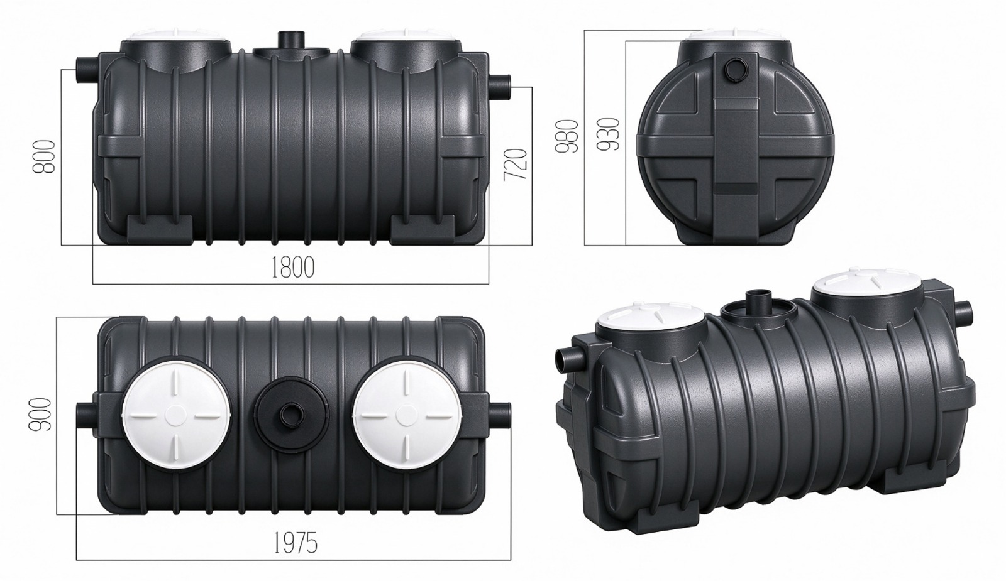
Confirm the H1/H2 measurement datum, connection envelope, access arrangements and site design before final set-out. PCGT is the existing product reference; POR is the supplier schedule reference.

Appendix A2 PCGT1500 supplier POR1500 drawing
Supplier drawing matched to the new dimension schedule. Dimensions are in millimetres. Do not scale.
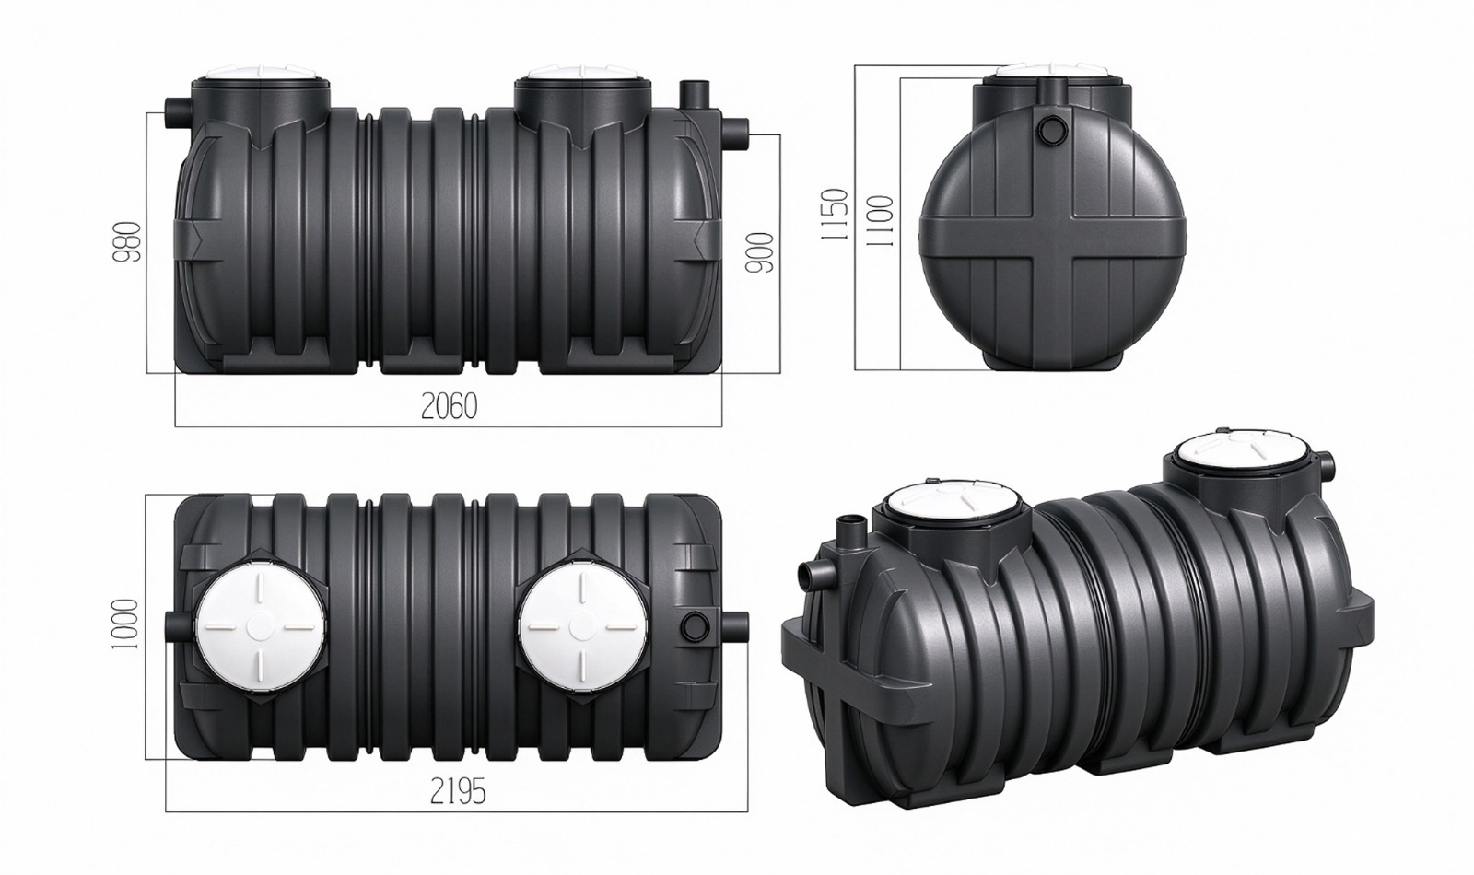
Confirm the H1/H2 measurement datum, connection envelope, access arrangements and site design before final set-out. PCGT is the existing product reference; POR is the supplier schedule reference.

Appendix A3 PCGT2000 supplier POR2000 drawing
Supplier drawing matched to the new dimension schedule. Dimensions are in millimetres. Do not scale.
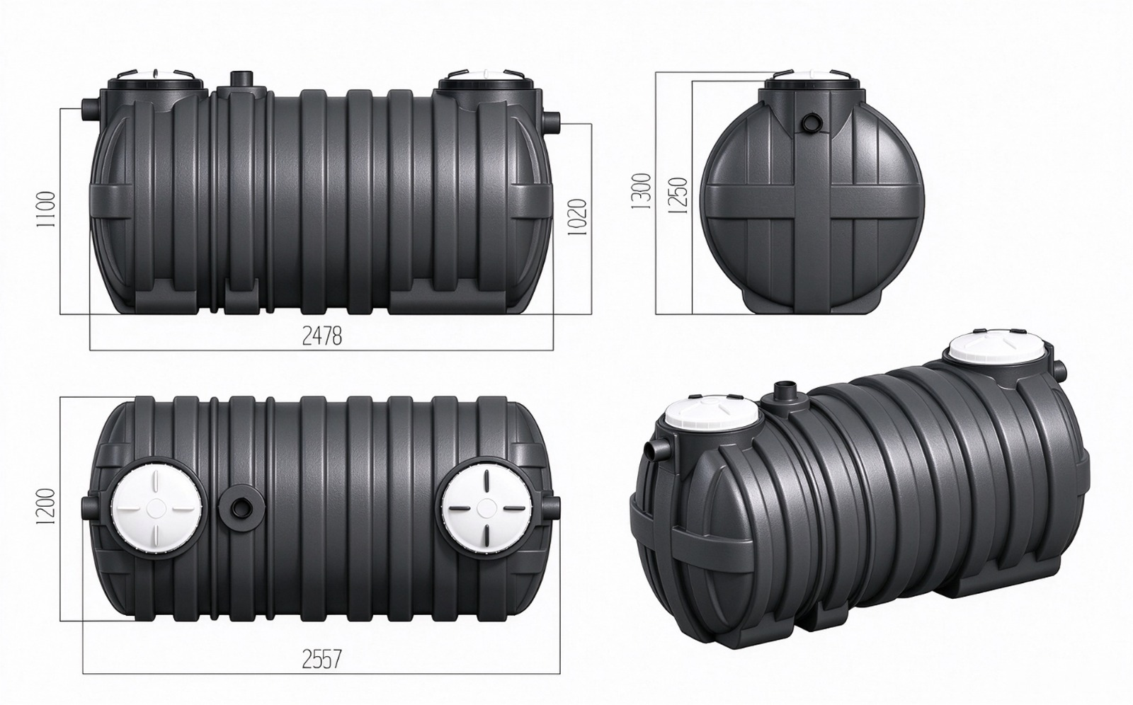
Confirm the H1/H2 measurement datum, connection envelope, access arrangements and site design before final set-out. PCGT is the existing product reference; POR is the supplier schedule reference.

Appendix A4 PCGT3000 supplier POR3000 drawing
Supplied POR3000 model drawing. Body dimensions 2565 x 1300 x 1400 mm, inlet H1 1180 mm and outlet H2 1090 mm. Do not scale.
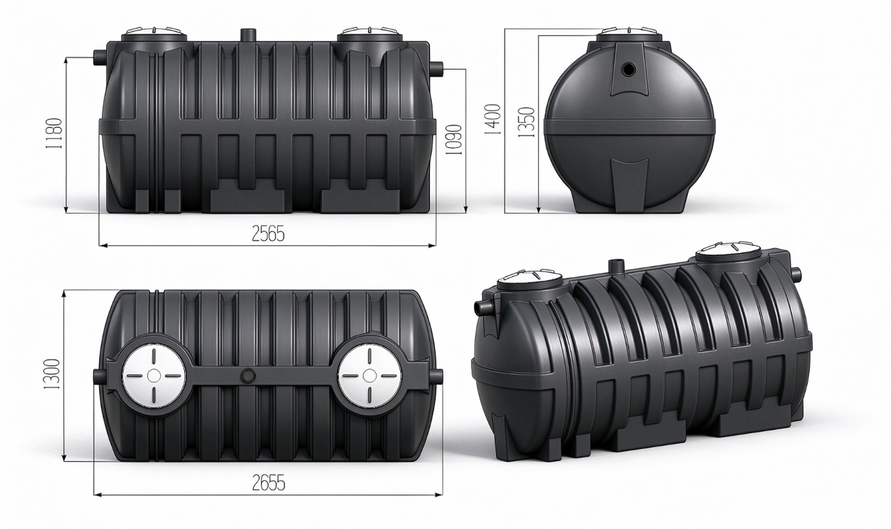
The drawing also shows an overall connection length of 2655 mm and a secondary height of 1350 mm. Confirm H1/H2 datum, connections, access arrangements and site design before final set-out.

Appendix A5 PCGT4000 supplier POR4000 drawing
Supplier drawing matched to the new dimension schedule. Dimensions are in millimetres. Do not scale.
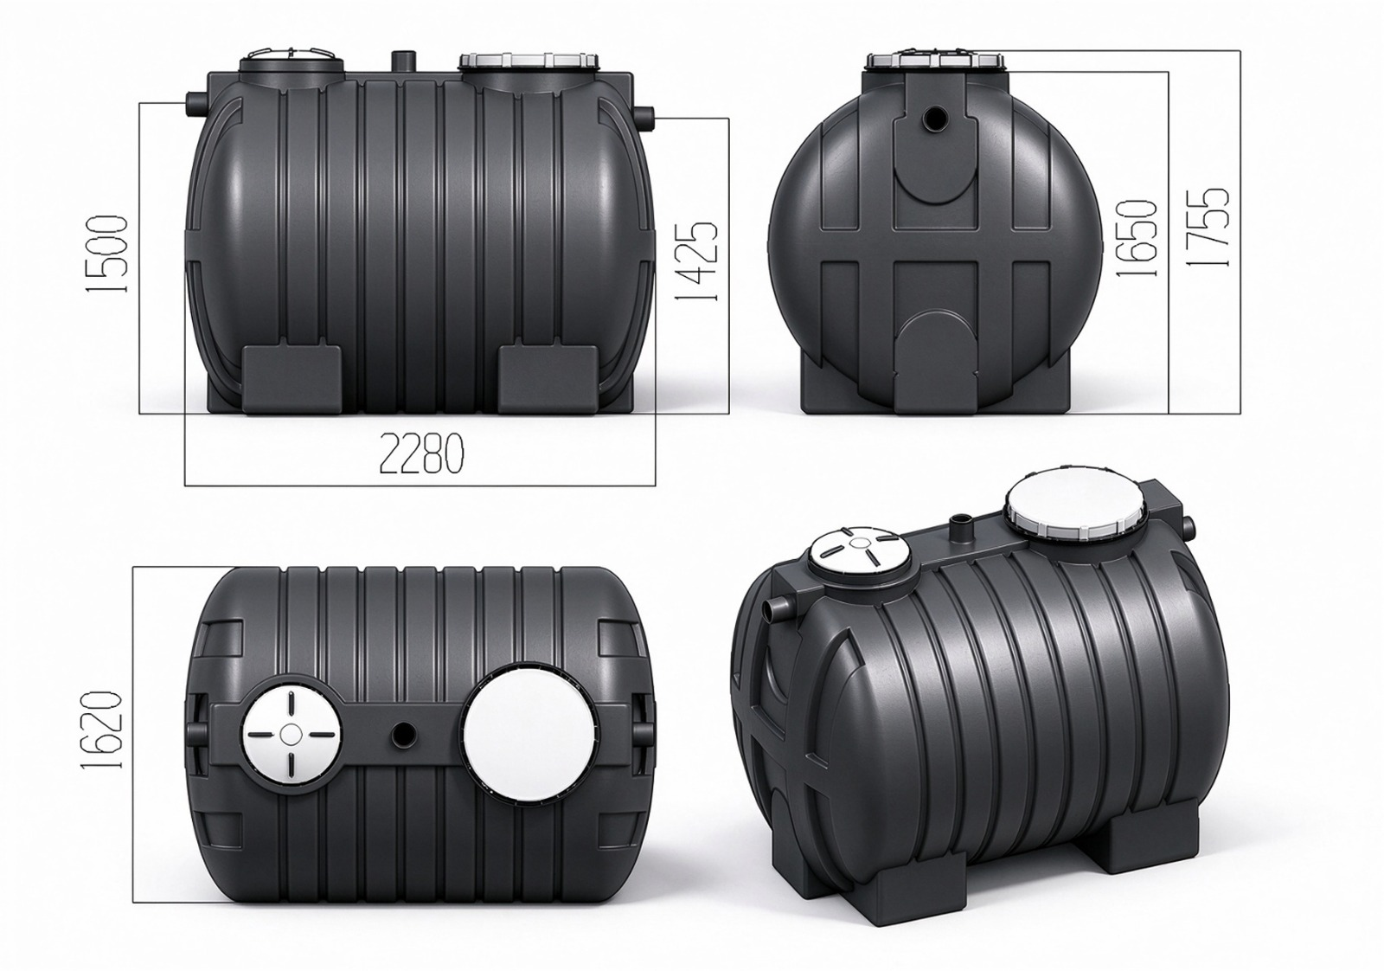
Confirm the H1/H2 measurement datum, connection envelope, access arrangements and site design before final set-out. PCGT is the existing product reference; POR is the supplier schedule reference.

Appendix A6 PCGT5000 supplier POR5000 drawing
Illustration adapted from the POR4000 drawing at Polyrib’s direction, with the length changed to 2660 mm. Other views and dimensions are retained. Do not scale.
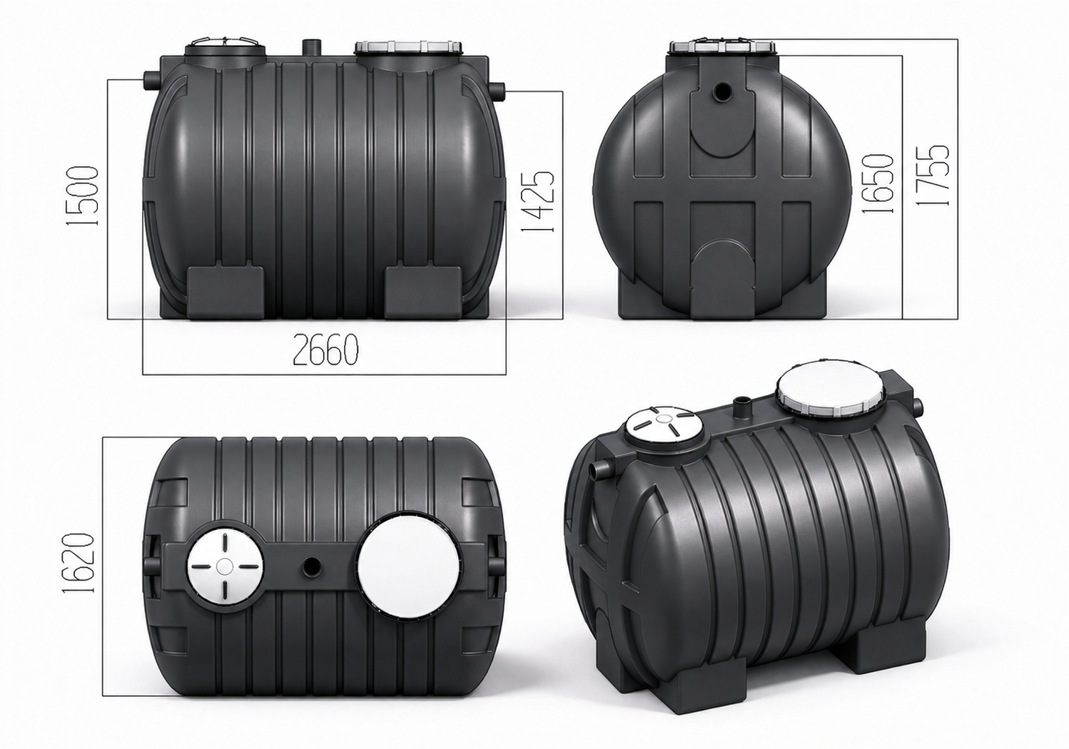
Confirm the H1/H2 measurement datum, connection envelope, access arrangements and site design before final set-out. PCGT is the existing product reference; POR is the supplier schedule reference.

